**CSE2004 J-COMPONENT**

**FACULTY: PROF. MURALI S**

***GROUP MEMBERS***

*SAUNAK SAHOO 16BCE2167*

*CORRINA MARIEANNE BARNABAS 16BCE0754*

**TOPIC:** Cricket Tournament Database Using SQL

ER Diagram

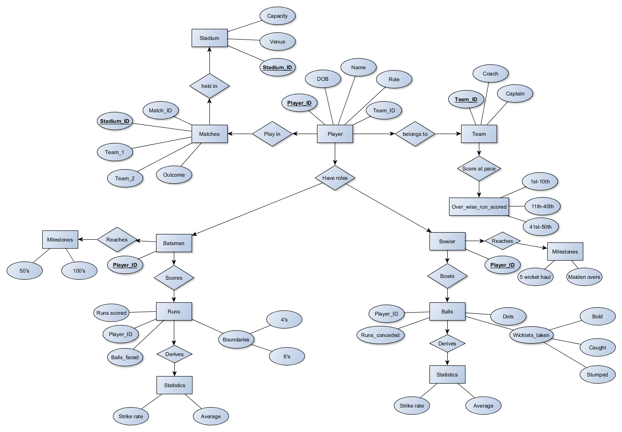

Relational Model

